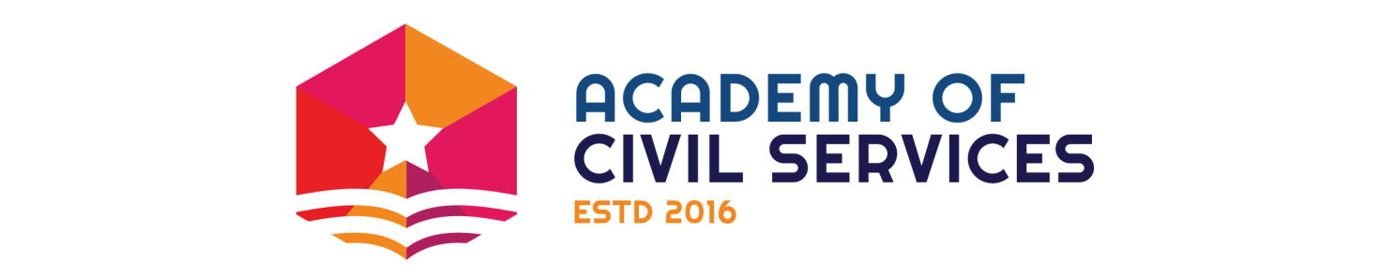
Daily Study Plan – Science & Technology

Topics to be covered:
1. Biotechnology
2. Information & Communication Technology
3. Space
4. Robotics & Artificial Intelligence
5. Nanotechnology
6. Nuclear Science
7. Defence Technology

Class | Class Instruction  (2 Hours)
Class 1 | Basics of Biotechnology
Class 2 | Genomics & Genetically Modified Organisms (GMO)
Class 3 | Applications of Biotechnology (1)
Class 4 | Applications of Biotechnology (2)
Class 5 | Information & Communication Technology
Class 6 | Introduction to Space Science
Class 7 | Orbits & Satellites
Class 8 | Launchers & Missions
Class 9 | Space Mains
Class 10 | Nanotechnology
Class 11 | Nuclear Technology
Class 12 | Robotics & AI (1)
Class 13 | Robotics & AI (2)
Class 14 | Defence

